Practical - 11
Practical Title: Student Management CRUD with Search and Filter

Problem Definition : Create a student management module to add, view, edit, delete, search and filter student records. All database operations must use MYSQLi statements and clear success/failure messages.

Theory
1. Are SELECT, INSERT, UPDATE, and DELETE operations working? Yes, SELECT, INSERT, UPDATE, and DELETE operations are implemented using MySQLi to view, add, edit, and delete student records.

2. Is search by name/email/course implemented? Yes, students can be searched by name or email and filtered by course and semester.

3. Are delete operations confirmed before execution? Yes, a JavaScript confirmation message appears before deleting a student record to prevent accidental deletion.

A. Evidence of Work (Screenshots):
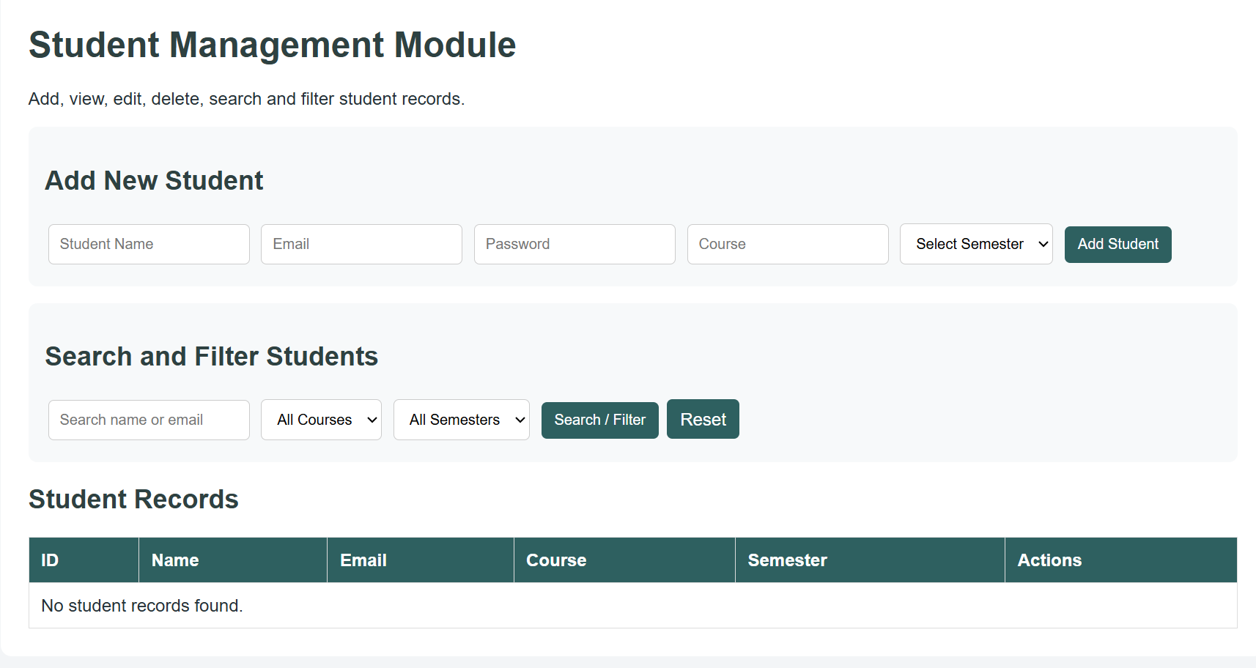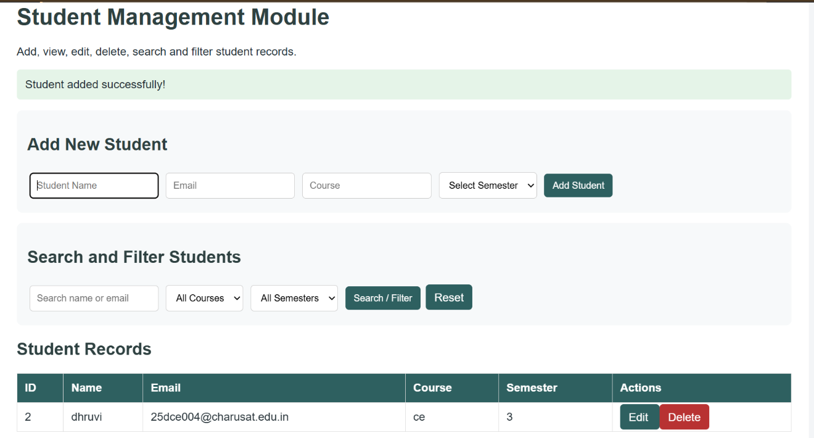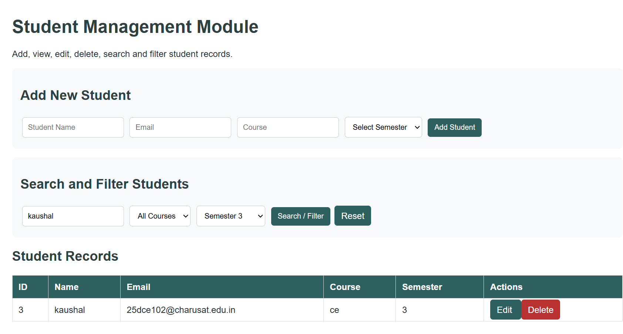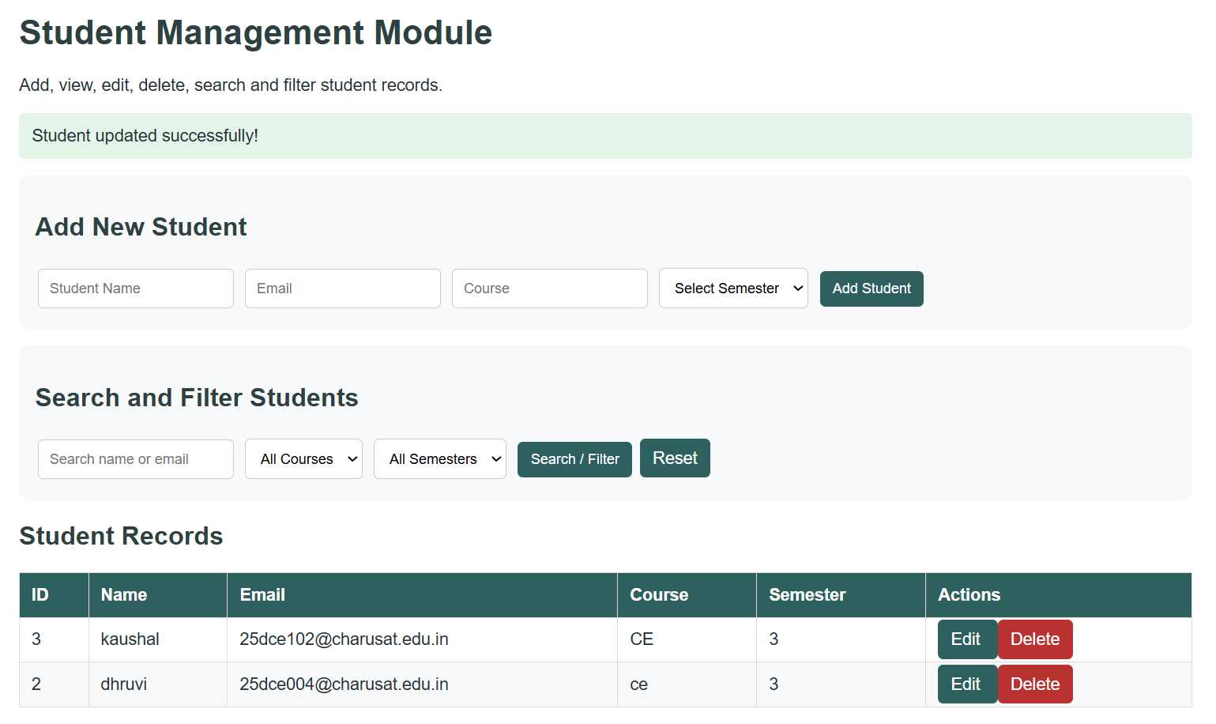
B.GitHub Repository Link:
https://github.com/Andarpadhruvi1125/Student-Hub-portal.git
C.Challenges Faced
During this Practical, I faced challenges in connecting PHP with the MySQL database using MySQLi and performing CRUD operations such as adding, viewing, updating, and deleting student records. I also faced difficulties implementing search and filter functionality and ensuring that student information was stored correctly in the database. I learned to identify and solve errors and display appropriate success and failure messages.
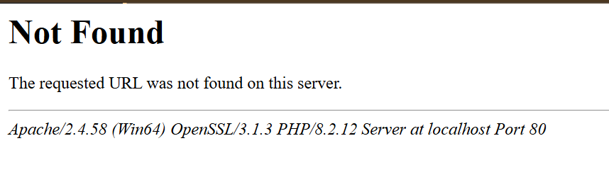
D.Learning Outcomes
Through this practical, I learned how to develop a Student Management Module using PHP and MySQLi. I understood how to perform INSERT, SELECT, UPDATE, and DELETE operations, search students by name and email, and filter records by course and semester. I also learned how to use prepared statements, confirm deletion before execution, and manage student records efficiently.
Faculty Remarks:

